Cairo University SEM-team 4

Faculty of Engineering

Computer Engineering Department

CMP 202

**Introduction to Database Systems**

Pharmacy database

Schema report

Team Number: 4

Team Members: -

-Salma Mouhamed sec:1 B.n:28

-Omar Salah SEC:2 b.n:2

-Nada Adel sec:2 b.n: 28

-Nourhan Gamal Mahmoud sec :2 B.n:32

Contact info: -

Somar3296@gmail.com

**ER Diagram**

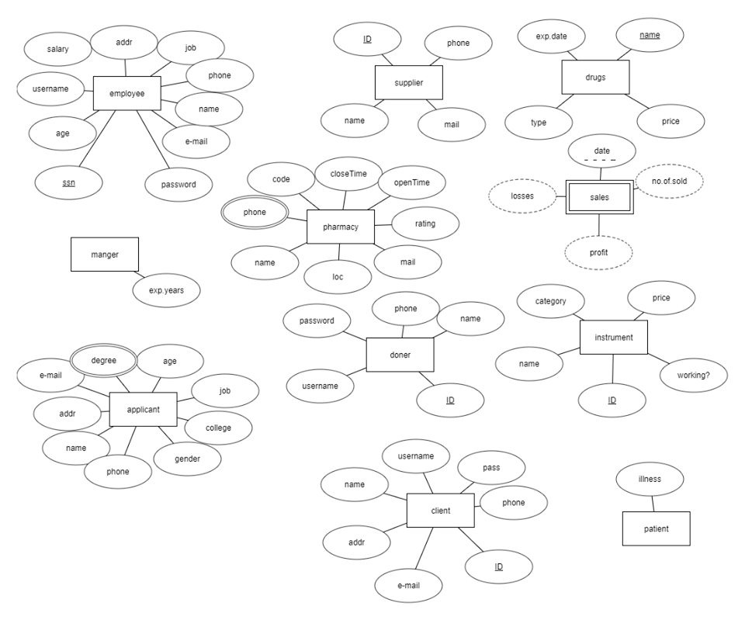

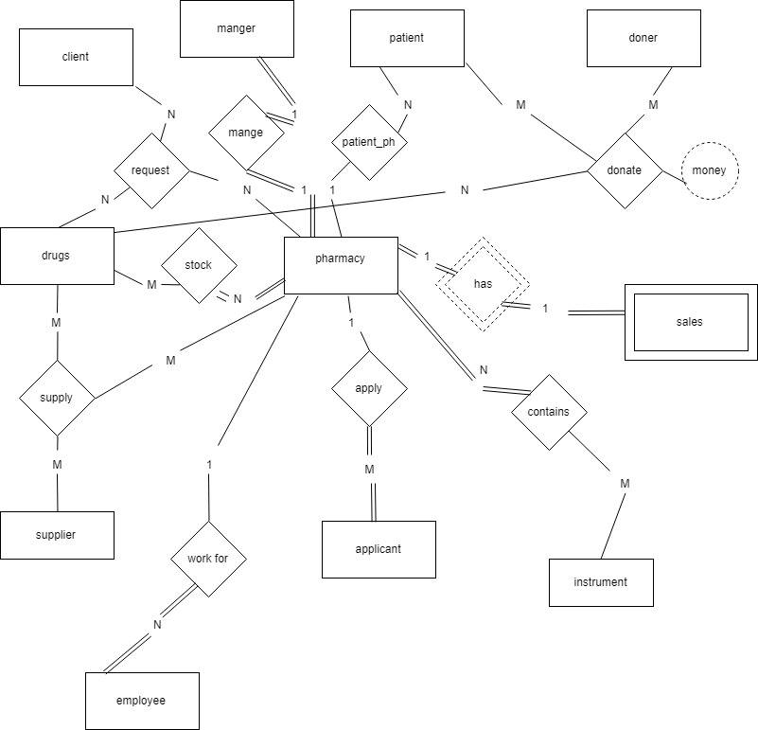

Pharmacy

|  |  |  |  |  |  |  |  |  |
| --- | --- | --- | --- | --- | --- | --- | --- | --- |
| Name | Close time | rating | Open time | Close time | e-mail | Loc. | Code | report |

Client

|  |  |  |  |  |  |  |  |
| --- | --- | --- | --- | --- | --- | --- | --- |
| name | phone | Addr. | username | password | e-mail | ID | report |

patient

|  |  |  |  |  |  |  |  |  |  |
| --- | --- | --- | --- | --- | --- | --- | --- | --- | --- |
| name | phone | Addr. | username | password | email | ID | illness | Ph. Code | report |

Employee

|  |  |  |  |  |  |  |  |  |  |  |  |
| --- | --- | --- | --- | --- | --- | --- | --- | --- | --- | --- | --- |
| name | phone | Addr. | username | password | email | salary | job | age | ssn | Ph. Code | report |

Manager

|  |  |  |  |  |  |  |  |  |  |  |  |  |
| --- | --- | --- | --- | --- | --- | --- | --- | --- | --- | --- | --- | --- |
| name | phone | Addr. | username | password | email | salary | job | age | ssn | Ph. Code | report | Exp.years |

Applicant

|  |  |  |  |  |  |  |  |  |  |
| --- | --- | --- | --- | --- | --- | --- | --- | --- | --- |
| name | phone | Addr. | age | gander | email | job | Deg. | college | Ph. Code |

Degree-Applicant

|  |  |
| --- | --- |
| e-mail | degree |

Supplier

|  |  |  |  |  |
| --- | --- | --- | --- | --- |
| name | phone | email | ID | report |

Drug

|  |  |  |  |
| --- | --- | --- | --- |
| name | Exp. date | price. | type |

Donor

|  |  |  |  |  |  |
| --- | --- | --- | --- | --- | --- |
| name | phone | username | password | ID | report |

Instrument

|  |  |  |  |  |  |
| --- | --- | --- | --- | --- | --- |
| name | category | type. | available | ID | Ph. Code |

Sales

|  |  |  |  |  |
| --- | --- | --- | --- | --- |
| profit | losses | Num. sold. | date | Ph. Code |

Contain (ph., drug)

|  |  |
| --- | --- |
| D.name | Ph. Code |

Request

|  |  |  |
| --- | --- | --- |
| Client.ID | Ph. Code | D.name |

Donate

|  |  |  |  |
| --- | --- | --- | --- |
| Donor.id | PATIENT.ID | D.name | money |

Supply

|  |  |  |
| --- | --- | --- |
| Sup.id | Ph. Code | D.name |

# **Constraints:**

**1.Key constraints:**

Pharmacy: Code

Client: Client .ID

Donor: Donor .ID

Patient: Patient .ID

Instrument: Instrument .ID

Drug: Drug name

Supplier: Supplier .ID

Sales: Date, ph.ID

Referential constraints:

|  |  |
| --- | --- |
| Foreign key | Primary key |
| Patient  (ph. code) | Pharmacy  (ph. code) |
| Employee  (ph. code) | Pharmacy  (ph. code) |
| Applicant  (ph. code) | Pharmacy  (ph. code) |
| Instrument  (ph. code) | Pharmacy  (ph. code) |
| Contain  (drug.name) | Drug  (name) |
| Contain  (ph. code) | Pharmacy  (ph. code) |
| Request  (client.ID) | Client  (ID) |
| Request  (ph. code) | Pharmacy  (code) |
| Request  (drug.name) | Drug  (name) |
| Donate  (donor.ID) | Donor  (ID) |
| Donate  (patient.ID) | Patient  (ID) |
| Donate  (drug.name) | Drug  (name) |
| Supply  (supplier.ID) | Supplier  (ID) |
| Supply  (ph. code) | Pharmacy  (code) |
| Supply  (drug.name) | Drug  (name) |
| Sales  (ph. code) | Pharmacy  (code) |

**Semantic constraints:**

* Pharmacy code: consists of 3numbers& one char.
* SSN: 10 digit consists of numbers only.
* Drug Name: Numbers & alphabetic.
* Close time must be after open time: the duration between them must be at least 16 hours.
* The minimum price of drugs which patient needs is 200 pounds max is 50000 pounds.
* Pass: 6 numbers & one capital & one small alphabetic at least.
* E-mail: check if the e-mail includes ‘@’ & “.com”.
* Name: don’t begin with number.
* Salary: min salary is 1200, max is 20000.
* Exp. Years: at least 3 years.
* Age of applicant is between 25 & 60.